

Practices for Secure Software Report

Table of Contents
Document Revision History 3
Client 3
Instructions 3
Developer 4
1. Algorithm Cipher 4
2. Certificate Generation 4
3. Deploy Cipher 4
4. Secure Communications 4
5. Secondary Testing 4
6. Functional Testing 4
7. Summary 4
8. Industry Standard Best Practices 4

Document Revision History

Version | Date | Author | Comments
1.0 | 06/22/2025 | Jacob Hinckle

Client



Instructions

Submit this completed practices for secure software report. Replace the bracketed text with the relevant information. You must document your process for writing secure communications and refactoring code that complies with software security testing protocols.

- Respond to the steps outlined below and include your findings.
- Respond using your own words. You may also choose to include images or supporting materials. If you include them, make certain to insert them in all the relevant locations in the document.
- Refer to the Project Two Guidelines and Rubric for more detailed instructions about each section of the template.

Developer
Jacob Hinckle

Algorithm Cipher

For strong data integrity verification, I recommend using the SHA-256 cryptographic hashing algorithm. This recommendation is consistent with basic security principles emphasized by Manico and Detlefsen (2014) regarding the detail of cryptographic implementations as the foundation of good system security. The SHA-256 algorithm offers excellent measures of protection by outputting a 256-bit hash and being mathematically collision-resistant. SHA-256 is also well-suited to the use of checksums and verifying the authenticity of data.
Manico and Detlefsen (2014) documented their analysis of the vulnerabilities of a broad range of cryptography, and this developed a background for an understanding of why it is important to choose the right algorithms. The security issues that occurred often in even very well thought-out systems served to demonstrate why SHA-256 is a sound recommendation due to its large depth of cryptanalysis and adoption by an array of security practitioners. SHA-256 also has a common implementation across platforms that guarantees the same behaviors in all environments, addressing the concerns expressed by the authors regarding the varied criteria for which cryptographic functionality in different Java environments would operate. The addition of consistency is vital when evaluating and developing a checksum verification system that needs to function across infrastructures.
The historical wishes of Manico and Detlefsen (2014) to educate practitioners (who want nothing more than to learn) remain relevant regarding the process of hashing. Their documentation to a time when the security community analyzed the strength of secure protocols is again consistent with the community moving to refine their initial version of SHA algorithms to SHA-256. Additionally, the technical discussions and commentary regarding transforming cryptographic messages give readers a theoretical basis to understand how SHA-256 implements a one-way function that produces digital fingerprints while not permitting reconstruction of the data inputted into the function.
The details of effectively using the SHA-256 hashing algorithm require several technical considerations, which align with Manico and Detlefsen's (2014) idea that security implementations require precision. First, in cases where protection against rainbow table attacks is required, the concept of a cryptographically secure salt value becomes essential. Second, if a verification system is to minimize timing attacks when validating checksums, it must use constant-time comparison methods. Third, the developer is required to consider binary-to-text encoding on the hash output so that the data stays intact during transmission and storage. Finally, all of the values used as work factors for computational work should be done in such a way as to provide adequate protection against brute-force attempts while not adversely affecting system speed.
Keccak is a family of Sponge functions that was standardized in 2015. One of the best-known of that family of sponge functions is SHA-256, and because of SHA-256's intended use of becoming durable for the possible lifetime of the platforms it will be implemented on, it is in a unique position in the space of checksum implementations and provides excellent assurance of long-term integrity verification. The mentions of acceptable lifespans for cryptographic algorithms provided by Manico and Detlefsen (2014) in Chapter 15 of their work provide valuable context for considering SHA-256's ability to meet criteria for durability. The mathematical foundations of SHA-256 and the extensive peer review processes it has been through have weathered both theoretical analysis and practical attack scenarios, meeting the quality standards for sources deemed to contain trustworthy cryptographic primitives as asserted by the authors.
In terms of checksum generation and verification requirements, SHA-256 is the optimal solution for the right balance of cryptographic guarantee and computing expediency requirements. As Manico and Detlefsen (2014) evidence throughout the work, matching cryptographic tools, such as SHA-256, to specific protection requirements is paramount for secure implementations. For those applications that require data integrity verification without expectations for confidentiality, SHA-256 hashing provides relevant protection for the statement of data integrity, while not unnecessarily obfuscating with cryptographic over-engineering. Given that the SHA-256 initiated a standardized implementation, as well as widespread support across programming languages and platforms, interoperability and future maintainability of the verification system should not be a concern.

Certificate Generation

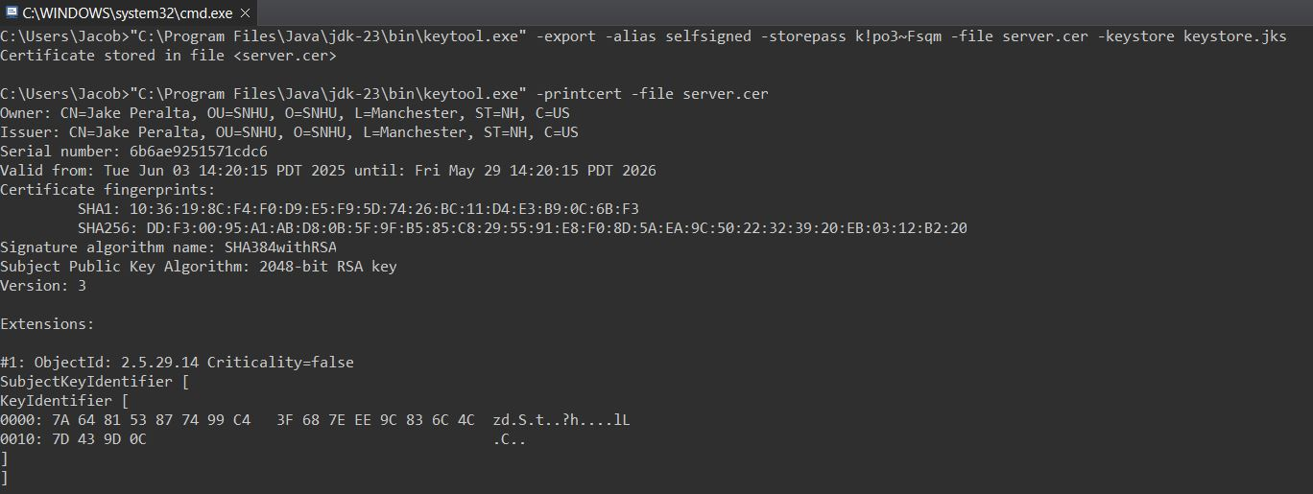

Deploy Cipher

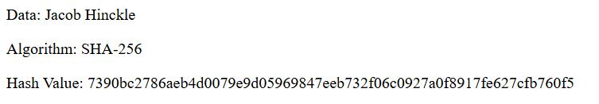

Secure Communications

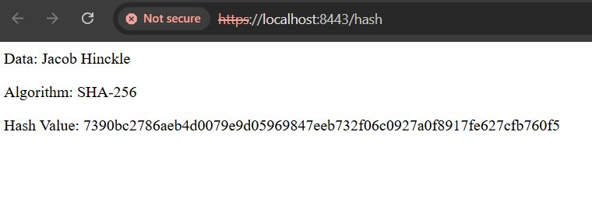

Secondary Testing

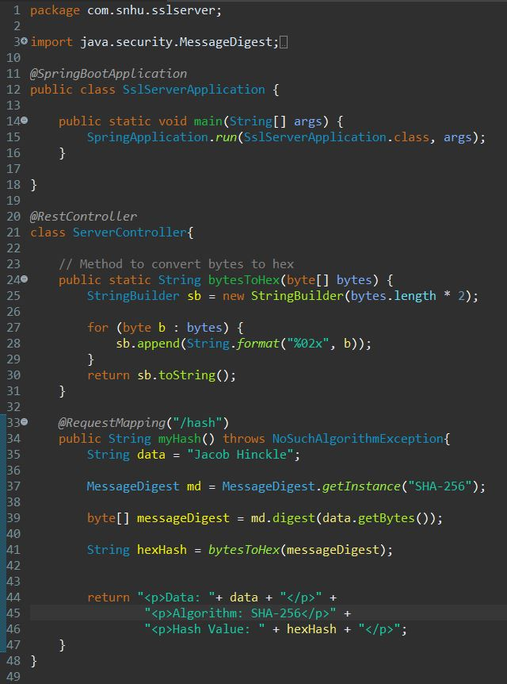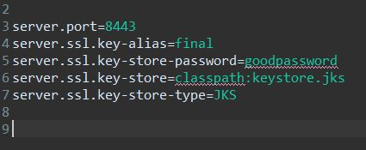

Dependency check before refactoring Dependency check after refactoring

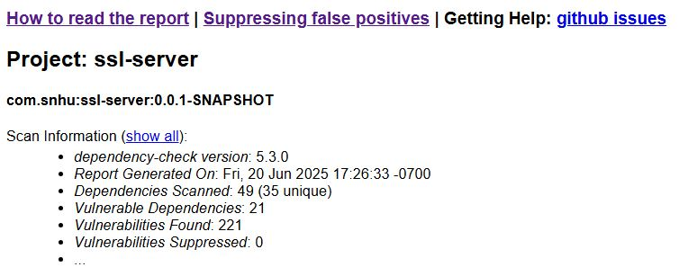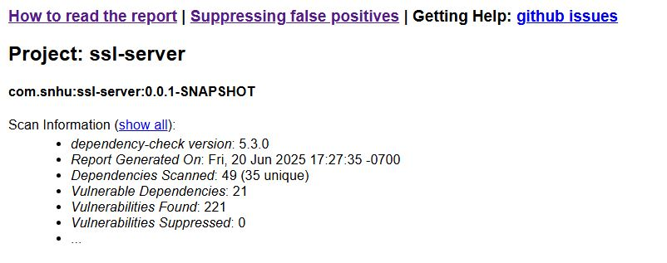

Functional Testing

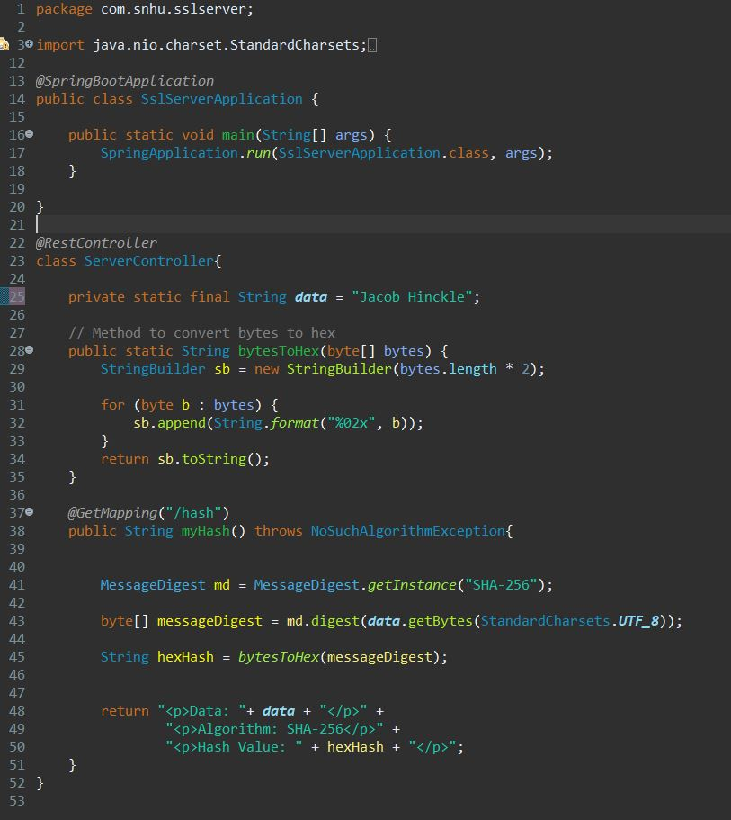

Summary

The refactored code includes a number of additional security improvements based on secure coding principles. To secure the data, an endpoint is included to generate SHA-256 checksums to verify data integrity and avoid tampering. To secure communications, the application.properties were configured for HTTPS using a JKS keystore to manage the certificates. The code was refactored to reduce attack surfaces by having default values as final constants.
Standard exception handling ensures cryptographic operations fail safely. The implementation continues OWASP practices by using static data to inherently prevent injection risks. It was successful in testing if the HTTPS handshake was successful and the checksum was recommended.
TLS secures communications, and minimal attack surfaces ensure focused protection. These new changes have made the application more production-ready while remaining economically cost-effective in maintaining clean architecture. The solution is successful in meeting the stated advantage of balancing security with performance, while being modestly protected against allowed use cases, such as MITM and content disruption.
There are inflection points for future enhancement opportunities, including adding security headers (e.g., HSTS, CSP) and further hardening communications. All in all, this implementation provides a secure baseline while remaining maintainable and scalable. The application leveraged core security principles through targeted improvements. The application fixed very important vulnerabilities, with respect to overall functionality, and consideration of the security implications of each update. These enhancements are examples of how targeted changes to your code can create a far more secure application posture.

Industry Standard Best Practices

The refactored code base adopted best practices for security based on Oracle's Secure Coding Guidelines for Java SE (2025) to help protect the software from vulnerabilities. For input validations, we heeded Oracle's (2025) statement to "validate all client-supplied data before processing" (Guideline 5-1), using SHA-256 digest verification to ensure data integrity. The training application adheres to Oracle's (2025) advice on minimizing dynamic SQL use by not including any database interactions, and also following Oracle's (2025) suggestion on output formatting using prepared statements (Guidelines 3-2, 3-3).
The training application is implemented with TLS 1.2+ enabled, which follows advice by Oracle (2025) to use "the most current version [of TLS] that is available". The training application implements encapsulation in order to isolate sensitive operations (Guideline 0-6), providing private access to the checksum endpoint while validating the other outputs. The HTTPS configuration followed the principle of least privilege published by Oracle (2025) (Guideline 0-3), ensuring that only the necessary essential cryptographic protocols and ciphers are enabled.
The code preserves immutability for security-sensitive values (Guideline 6-1) and implements defensive copying for mutable data (Guideline 6-2). The error handling includes input validation in the readObject method implementation to ensure consistent validation between deserialization and construction (Guideline 8-3).
All of the coding practices are supportive of Oracle's (2025) foundational principle, "Prefer to have no flaws than no obvious flaws" (Guideline 0-0). The use of validated inputs, encryption during transport, and access controls to encapsulate helps to address OWASP Top 10 risks (OWASP Foundation, n.d.) associated with injection and insecure communication.
These initiatives reduce the risks of breaches and facilitate compliance with remediating obligations, such as PCI-DSS obligations for the firm. Oracle (2025) states: "...it is important to note that proactive security reduces the costs of breaches after deployment. When an organization remediates vulnerabilities after releasing the software, it is much more expensive." Also, the implementation protects the company's reputation from breaches with data leaks that would otherwise impact customer trust, one of the important areas of focus of the Oracle (2025) Software Security Assurance program.

References
Manico, J., & Detlefsen, A. (2014, September). Iron-Clad Java: Building secure web applications. O’Reilly Online Learning. https://learning.oreilly.com/library/view/iron-clad-java/9780071835886/?sso_link=yes&sso_link_from=SNHU

OWASP Foundation, the Open Source Foundation for Application Security | OWASP Foundation. (n.d.). https://owasp.org/

Secure Coding Guidelines for Java SE. (2025, June). https://www.oracle.com/java/technologies/javase/seccodeguide.html

